Bahria University,

Karachi Campus



LAB EXPERIMENT NO.

**07**

LIST OF TASKS

|  |  |
| --- | --- |
| TASK NO | OBJECTIVE |
| 1 | **The FCFS source code given above assumes that the arrival times for processes are provided in ascending order of time. Modify the code in C language for random process arrival times.** |
| 2 | **Modify the FCFS code of example#02 to be able to calculate the mean of Normalized Turnaround Time. Also, the modified code should display the Normalized Turnaround Time of each process.** |
| 3 | **Implement the Shortest Job First algorithm with the help of 4 non-preemptive processes.** |

Submitted On:

**23-May-2022**

**Task No. 1: The FCFS source code given above assumes that the arrival times for processes are provided in ascending order of time. Modify the code in C language for random process arrival times.**

**Solution & Output**:

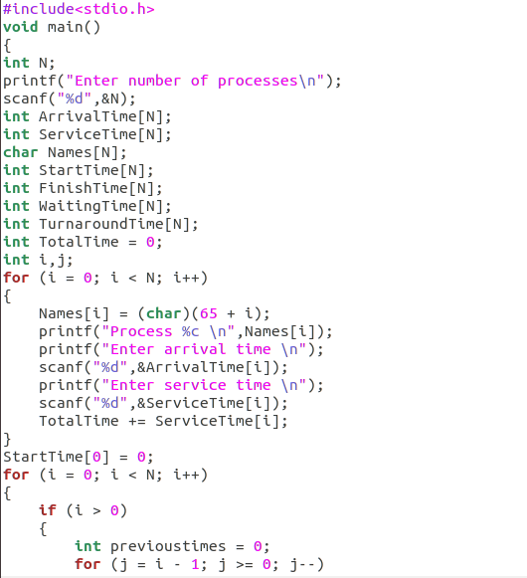

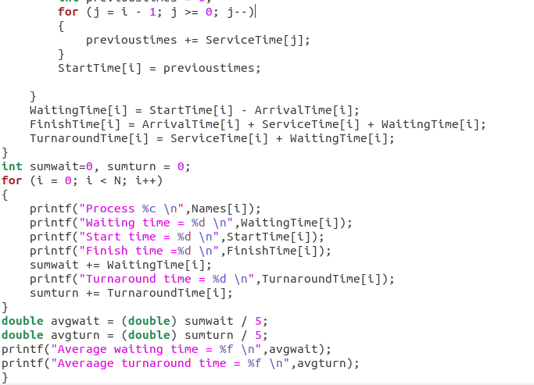

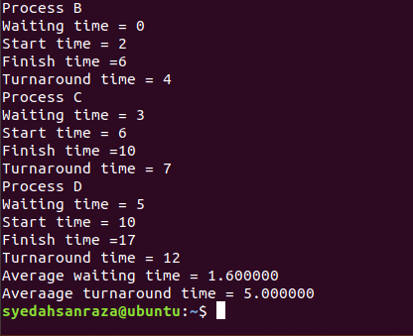

**Task No. 2: Modify the FCFS code of example#02 to be able to calculate the mean of Normalized Turnaround Time. Also, the modified code should display the Normalized Turnaround Time of each process.**

**Solution:**

**Output:**

**Task No. 3: Implement the Shortest Job First algorithm with the help of 4 non-preemptive processes.**

**Solution:**

**Output**: